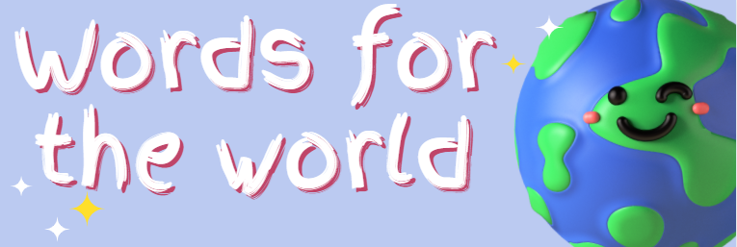
Name | Age Category (delete as appropriate)  P1 – P4 S1 – S3  P5 – P7 S4 – S6
School | Local Authority
In which language is your entry?

What is the title of your entry?

Original Text | English Translation
What would you say is the main message that you want to get across to the world in your entry? (Please ensure this section is completed as it forms part of the judging criteria)

